# Celeste Matute

## Module 2 Assignment 2

library(tidyverse)

## ── Attaching packages ─────────────────────────────────────── tidyverse 1.3.0 ──

## ✓ ggplot2 3.3.3 ✓ purrr 0.3.4  
## ✓ tibble 3.0.5 ✓ dplyr 1.0.3  
## ✓ tidyr 1.1.2 ✓ stringr 1.4.0  
## ✓ readr 1.4.0 ✓ forcats 0.5.1

## ── Conflicts ────────────────────────────────────────── tidyverse_conflicts() ──  
## x dplyr::filter() masks stats::filter()  
## x dplyr::lag() masks stats::lag()

library(tidymodels)

## ── Attaching packages ────────────────────────────────────── tidymodels 0.1.2 ──

## ✓ broom 0.7.3 ✓ recipes 0.1.15  
## ✓ dials 0.0.9 ✓ rsample 0.0.8   
## ✓ infer 0.5.4 ✓ tune 0.1.2   
## ✓ modeldata 0.1.0 ✓ workflows 0.2.1   
## ✓ parsnip 0.1.5 ✓ yardstick 0.0.7

## ── Conflicts ───────────────────────────────────────── tidymodels_conflicts() ──  
## x scales::discard() masks purrr::discard()  
## x dplyr::filter() masks stats::filter()  
## x recipes::fixed() masks stringr::fixed()  
## x dplyr::lag() masks stats::lag()  
## x yardstick::spec() masks readr::spec()  
## x recipes::step() masks stats::step()

library(glmnet)

## Loading required package: Matrix

##   
## Attaching package: 'Matrix'

## The following objects are masked from 'package:tidyr':  
##   
## expand, pack, unpack

## Loaded glmnet 4.1

library(GGally)

## Registered S3 method overwritten by 'GGally':  
## method from   
## +.gg ggplot2

library(ggcorrplot)   
library(MASS)

##   
## Attaching package: 'MASS'

## The following object is masked from 'package:dplyr':  
##   
## select

library(leaps)   
library(lmtest)

## Loading required package: zoo

##   
## Attaching package: 'zoo'

## The following objects are masked from 'package:base':  
##   
## as.Date, as.Date.numeric

library(lubridate)

##   
## Attaching package: 'lubridate'

## The following objects are masked from 'package:base':  
##   
## date, intersect, setdiff, union

library(splines)  
library(car)

## Loading required package: carData

##   
## Attaching package: 'car'

## The following object is masked from 'package:dplyr':  
##   
## recode

## The following object is masked from 'package:purrr':  
##   
## some

bike_cleaned <- read_csv("bike_cleaned.csv")

##   
## ── Column specification ────────────────────────────────────────────────────────  
## cols(  
## instant = col_double(),  
## dteday = col_character(),  
## season = col_character(),  
## mnth = col_character(),  
## hr = col_double(),  
## holiday = col_character(),  
## weekday = col_character(),  
## workingday = col_character(),  
## weathersit = col_character(),  
## temp = col_double(),  
## atemp = col_double(),  
## hum = col_double(),  
## windspeed = col_double(),  
## casual = col_double(),  
## registered = col_double(),  
## count = col_double()  
## )

bike<-bike_cleaned

Conversions

bike = bike %>% mutate(dteday = mdy(dteday))  
bike = bike %>% mutate(season = as_factor(season))  
bike = bike %>% mutate(mnth = as_factor(mnth))  
bike = bike %>% mutate(holiday = as_factor(holiday))  
bike = bike %>% mutate(weekday = as_factor(weekday))  
bike = bike %>% mutate(workingday = as_factor(workingday))  
bike = bike %>% mutate(weathersit = as_factor(weathersit))  
bike = bike %>% mutate(hr = as_factor(hr))

Correlations

ggcorr(bike, label = "TRUE", label_round = 2)

## Warning in ggcorr(bike, label = "TRUE", label_round = 2): data in column(s)  
## 'dteday', 'season', 'mnth', 'hr', 'holiday', 'weekday', 'workingday',  
## 'weathersit' are not numeric and were ignored

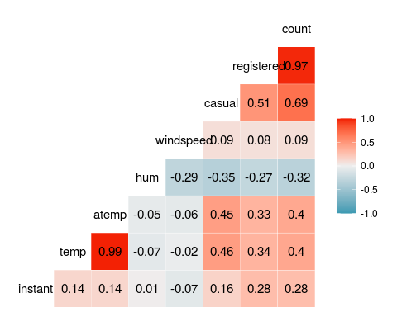

ggplot(bike,aes(x=season,y=count)) + geom_boxplot() + theme_bw()

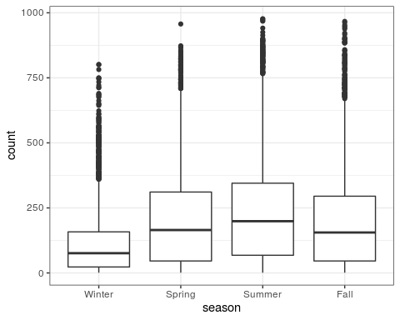

ggplot(bike,aes(x=mnth,y=count)) + geom_boxplot() + theme_bw()

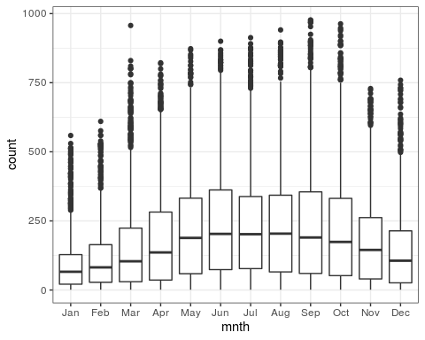

ggplot(bike,aes(x=hr,y=count)) + geom_boxplot() + theme_bw()

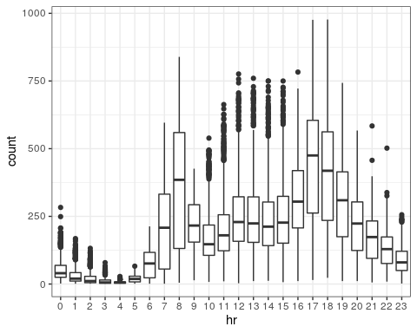

ggplot(bike,aes(x=holiday,y=count)) + geom_boxplot() + theme_bw()

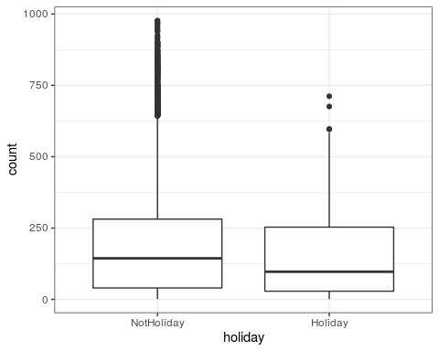

ggplot(bike,aes(x=weekday,y=count)) + geom_boxplot() + theme_bw()

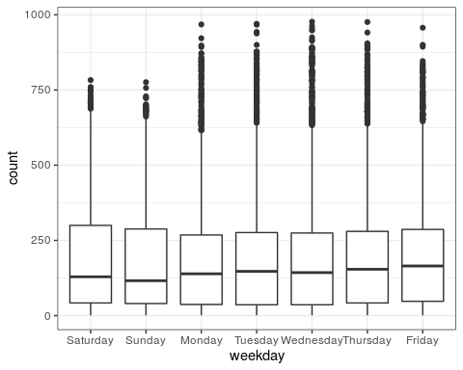

ggplot(bike,aes(x=workingday,y=count)) + geom_boxplot() + theme_bw()

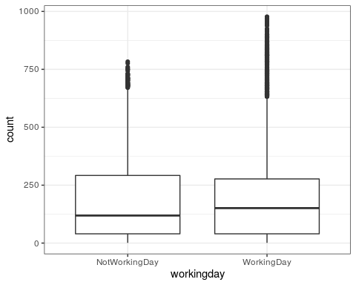

ggplot(bike,aes(x=weathersit,y=count)) + geom_boxplot() + theme_bw()

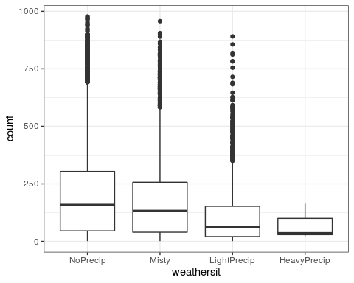

The boxplots showed that the categories most effected were the month of the year, the day of the week, the weather, the season and hour of the day. The most correlated variable with a count was the temperature.

Correlation Model

bike_recipe = recipe(count ~ hr , bike)  
lm_model=  
 linear_reg() %>%  
 set_engine("lm")  
lm_wflow =  
 workflow() %>%  
 add_model(lm_model) %>%  
 add_recipe(bike_recipe)  
lm_fit=fit(lm_wflow,bike)

summary(lm_fit$fit$fit$fit)

##   
## Call:  
## stats::lm(formula = ..y ~ ., data = data)  
##   
## Residuals:  
## Min 1Q Median 3Q Max   
## -446.45 -60.99 -6.01 50.10 551.49   
##   
## Coefficients:  
## Estimate Std. Error t value Pr(>|t|)   
## (Intercept) 53.898 4.756 11.332 < 2e-16 ***  
## hr1 -20.522 6.731 -3.049 0.002300 **   
## hr2 -31.028 6.752 -4.595 4.35e-06 ***  
## hr3 -42.171 6.796 -6.205 5.58e-10 ***  
## hr4 -47.545 6.796 -6.996 2.73e-12 ***  
## hr5 -34.008 6.747 -5.040 4.70e-07 ***  
## hr6 22.146 6.729 3.291 0.000999 ***  
## hr7 158.167 6.724 23.523 < 2e-16 ***  
## hr8 305.113 6.724 45.377 < 2e-16 ***  
## hr9 165.411 6.724 24.600 < 2e-16 ***  
## hr10 119.770 6.724 17.812 < 2e-16 ***  
## hr11 154.245 6.724 22.939 < 2e-16 ***  
## hr12 199.418 6.722 29.668 < 2e-16 ***  
## hr13 199.763 6.719 29.729 < 2e-16 ***  
## hr14 187.051 6.719 27.838 < 2e-16 ***  
## hr15 197.335 6.719 29.368 < 2e-16 ***  
## hr16 258.085 6.717 38.422 < 2e-16 ***  
## hr17 407.554 6.717 60.674 < 2e-16 ***  
## hr18 371.613 6.722 55.286 < 2e-16 ***  
## hr19 257.625 6.722 38.327 < 2e-16 ***  
## hr20 172.132 6.722 25.608 < 2e-16 ***  
## hr21 118.416 6.722 17.617 < 2e-16 ***  
## hr22 77.437 6.722 11.520 < 2e-16 ***  
## hr23 33.933 6.722 5.048 4.50e-07 ***  
## ---  
## Signif. codes: 0 '***' 0.001 '**' 0.01 '*' 0.05 '.' 0.1 ' ' 1  
##   
## Residual standard error: 128.2 on 17355 degrees of freedom  
## Multiple R-squared: 0.5015, Adjusted R-squared: 0.5008   
## F-statistic: 759.1 on 23 and 17355 DF, p-value: < 2.2e-16

The R squared value is at .5 and that is compared to the other variables where their R squared value was around .02 and .07. All the hours were also significant, showing this model was a good predictor.

Ridge Model

bike_recipe2 = recipe(count ~ ., bike) %>%  
 step_ns(temp, deg_free = 4) %>%  
 step_rm("instant", "dteday", "registered", "casual") %>%  
 step_dummy(all_nominal()) %>%   
 step_center(all_predictors()) %>%   
 step_scale(all_predictors())   
   
   
ridge_model =   
 linear_reg(mixture = 0 ) %>%   
 set_engine("glmnet")   
  
ridge_wflow =   
 workflow() %>%   
 add_model(ridge_model) %>%   
 add_recipe(bike_recipe2)  
  
ridge_fit = fit(ridge_wflow, bike)

plot(ridge_fit$fit$fit$fit$lambda,ridge_fit$fit$fit$fit$dev.ratio)

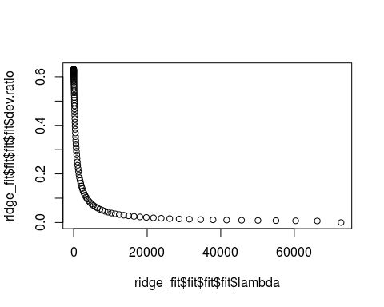

ridge_fit %>%  
 pull_workflow_fit() %>%  
 pluck("fit")

##   
## Call: glmnet::glmnet(x = maybe_matrix(x), y = y, family = "gaussian", alpha = ~0)   
##   
## Df %Dev Lambda  
## 1 55 0.00 72720  
## 2 55 0.64 66260  
## 3 55 0.70 60370  
## 4 55 0.77 55010  
## 5 55 0.85 50120  
## 6 55 0.93 45670  
## 7 55 1.02 41610  
## 8 55 1.11 37920  
## 9 55 1.22 34550  
## 10 55 1.34 31480  
## 11 55 1.46 28680  
## 12 55 1.60 26130  
## 13 55 1.75 23810  
## 14 55 1.92 21700  
## 15 55 2.10 19770  
## 16 55 2.29 18010  
## 17 55 2.51 16410  
## 18 55 2.74 14960  
## 19 55 2.99 13630  
## 20 55 3.27 12420  
## 21 55 3.56 11310  
## 22 55 3.89 10310  
## 23 55 4.24 9392  
## 24 55 4.62 8558  
## 25 55 5.03 7798  
## 26 55 5.47 7105  
## 27 55 5.95 6474  
## 28 55 6.46 5899  
## 29 55 7.01 5375  
## 30 55 7.61 4897  
## 31 55 8.24 4462  
## 32 55 8.92 4066  
## 33 55 9.65 3705  
## 34 55 10.42 3375  
## 35 55 11.24 3076  
## 36 55 12.11 2802  
## 37 55 13.03 2553  
## 38 55 14.00 2327  
## 39 55 15.02 2120  
## 40 55 16.10 1932  
## 41 55 17.22 1760  
## 42 55 18.40 1604  
## 43 55 19.62 1461  
## 44 55 20.88 1331  
## 45 55 22.19 1213  
## 46 55 23.55 1105  
## 47 55 24.94 1007  
## 48 55 26.36 918  
## 49 55 27.81 836  
## 50 55 29.29 762  
## 51 55 30.78 694  
## 52 55 32.29 632  
## 53 55 33.81 576  
## 54 55 35.33 525  
## 55 55 36.85 478  
## 56 55 38.35 436  
## 57 55 39.84 397  
## 58 55 41.30 362  
## 59 55 42.73 330  
## 60 55 44.12 300  
## 61 55 45.47 274  
## 62 55 46.78 250  
## 63 55 48.03 227  
## 64 55 49.22 207  
## 65 55 50.36 189  
## 66 55 51.43 172  
## 67 55 52.44 157  
## 68 55 53.39 143  
## 69 55 54.27 130  
## 70 55 55.09 118  
## 71 55 55.85 108  
## 72 55 56.54 98  
## 73 55 57.18 90  
## 74 55 57.77 82  
## 75 55 58.30 74  
## 76 55 58.78 68  
## 77 55 59.22 62  
## 78 55 59.61 56  
## 79 55 59.97 51  
## 80 55 60.30 47  
## 81 55 60.59 43  
## 82 55 60.85 39  
## 83 55 61.09 35  
## 84 55 61.31 32  
## 85 55 61.51 29  
## 86 55 61.68 27  
## 87 55 61.85 24  
## 88 55 62.00 22  
## 89 55 62.14 20  
## 90 55 62.26 18  
## 91 55 62.38 17  
## 92 55 62.49 15  
## 93 55 62.59 14  
## 94 55 62.68 13  
## 95 55 62.77 12  
## 96 55 62.86 11  
## 97 55 62.93 10  
## 98 55 63.00 9  
## 99 55 63.07 8  
## 100 55 63.13 7

The R squared value was 63 because we used the lambada of 9.

ridge_fit %>%  
 pull_workflow_fit() %>%  
 pluck("fit") %>%   
 coef(s = 9)

## 56 x 1 sparse Matrix of class "dgCMatrix"  
## 1  
## (Intercept) 189.46308763  
## atemp 29.37584344  
## hum -24.99608563  
## windspeed -3.48078739  
## temp_ns_1 -0.08483601  
## temp_ns_2 30.41663952  
## temp_ns_3 0.82250180  
## temp_ns_4 3.80461416  
## season_Spring 10.96037896  
## season_Summer 4.37276040  
## season_Fall 22.14569936  
## mnth_Feb 1.00209711  
## mnth_Mar 4.35927571  
## mnth_Apr 2.70013232  
## mnth_May 2.92853725  
## mnth_Jun -3.34284365  
## mnth_Jul -6.55019381  
## mnth_Aug -1.43534527  
## mnth_Sep 7.00876668  
## mnth_Oct 6.38376985  
## mnth_Nov 2.70006180  
## mnth_Dec 2.69937151  
## hr_X1 -15.61264033  
## hr_X2 -16.93978317  
## hr_X3 -18.52190949  
## hr_X4 -18.78177449  
## hr_X5 -15.97665441  
## hr_X6 -4.96458753  
## hr_X7 20.47353589  
## hr_X8 46.84357422  
## hr_X9 18.10448033  
## hr_X10 7.22391274  
## hr_X11 11.61848185  
## hr_X12 18.76005181  
## hr_X13 17.54925690  
## hr_X14 14.32962681  
## hr_X15 16.06355368  
## hr_X16 27.98943852  
## hr_X17 57.60591917  
## hr_X18 51.66924741  
## hr_X19 31.25521086  
## hr_X20 16.38080028  
## hr_X21 7.26730423  
## hr_X22 0.50692131  
## hr_X23 -6.66553274  
## holiday_Holiday -4.45136357  
## weekday_Sunday -4.67930451  
## weekday_Monday -2.14409069  
## weekday_Tuesday -1.21396320  
## weekday_Wednesday -0.20951399  
## weekday_Thursday -0.60123974  
## weekday_Friday 1.25315857  
## workingday_WorkingDay -0.54338480  
## weathersit_Misty -1.67747995  
## weathersit_LightPrecip -14.33129994  
## weathersit_HeavyPrecip -0.36852770

LASSO Method

bike_recipe3 = recipe(count ~ ., bike) %>%  
 step_ns(temp, deg_free = 4) %>%  
 step_rm("instant", "dteday", "registered", "casual") %>%  
 step_dummy(all_nominal()) %>%   
 step_center(all_predictors()) %>%   
 step_scale(all_predictors())   
lasso_model =   
 linear_reg(mixture = 1 ) %>%   
 set_engine("glmnet")   
lasso_wflow =   
 workflow() %>%   
 add_model(lasso_model) %>%   
 add_recipe(bike_recipe3)  
lasso_fit = fit(lasso_wflow, bike)

lasso_fit %>%  
 pull_workflow_fit() %>%  
 pluck("fit")

##   
## Call: glmnet::glmnet(x = maybe_matrix(x), y = y, family = "gaussian", alpha = ~1)   
##   
## Df %Dev Lambda  
## 1 0 0.00 72.720  
## 2 1 2.73 66.260  
## 3 1 4.99 60.370  
## 4 3 7.91 55.010  
## 5 3 11.96 50.120  
## 6 4 15.82 45.670  
## 7 4 19.53 41.610  
## 8 5 22.97 37.920  
## 9 5 26.57 34.550  
## 10 5 29.55 31.480  
## 11 7 32.35 28.680  
## 12 10 35.31 26.130  
## 13 11 38.41 23.810  
## 14 11 41.11 21.700  
## 15 12 43.43 19.770  
## 16 14 45.48 18.010  
## 17 15 47.53 16.410  
## 18 15 49.33 14.960  
## 19 16 50.92 13.630  
## 20 17 52.27 12.420  
## 21 18 53.49 11.310  
## 22 18 54.54 10.310  
## 23 21 55.43 9.392  
## 24 22 56.28 8.558  
## 25 23 57.04 7.798  
## 26 25 57.73 7.105  
## 27 27 58.37 6.474  
## 28 27 58.95 5.899  
## 29 28 59.44 5.375  
## 30 28 59.89 4.897  
## 31 30 60.27 4.462  
## 32 31 60.61 4.066  
## 33 32 60.93 3.705  
## 34 33 61.21 3.375  
## 35 34 61.44 3.076  
## 36 34 61.64 2.802  
## 37 36 61.82 2.553  
## 38 36 62.11 2.327  
## 39 39 62.32 2.120  
## 40 39 62.48 1.932  
## 41 39 62.63 1.760  
## 42 39 62.74 1.604  
## 43 39 62.84 1.461  
## 44 40 62.93 1.331  
## 45 41 63.04 1.213  
## 46 41 63.14 1.105  
## 47 41 63.22 1.007  
## 48 41 63.28 0.918  
## 49 41 63.32 0.836  
## 50 42 63.36 0.762  
## 51 43 63.39 0.694  
## 52 45 63.42 0.632  
## 53 45 63.46 0.576  
## 54 46 63.49 0.525  
## 55 46 63.52 0.478  
## 56 49 63.54 0.436  
## 57 50 63.56 0.397  
## 58 49 63.59 0.362  
## 59 50 63.61 0.330  
## 60 50 63.62 0.300  
## 61 50 63.64 0.274  
## 62 50 63.65 0.250  
## 63 51 63.66 0.227  
## 64 52 63.67 0.207  
## 65 52 63.67 0.189  
## 66 52 63.68 0.172  
## 67 52 63.69 0.157  
## 68 52 63.69 0.143  
## 69 52 63.69 0.130  
## 70 52 63.70 0.118  
## 71 52 63.70 0.108  
## 72 52 63.70 0.098  
## 73 52 63.70 0.090  
## 74 52 63.71 0.082  
## 75 53 63.71 0.074  
## 76 53 63.71 0.068  
## 77 53 63.71 0.062  
## 78 53 63.71 0.056  
## 79 53 63.71 0.051  
## 80 54 63.71 0.047

The lambada of 1.213 is an R squared value of 63.04.

lasso_fit %>%  
 pull_workflow_fit() %>%  
 pluck("fit") %>%   
 coef(s = 1.213)

## 56 x 1 sparse Matrix of class "dgCMatrix"  
## 1  
## (Intercept) 189.46308763  
## atemp 34.80158293  
## hum -25.67971384  
## windspeed -2.11331651  
## temp_ns_1 .   
## temp_ns_2 28.78585749  
## temp_ns_3 .   
## temp_ns_4 .   
## season_Spring 10.22668109  
## season_Summer .   
## season_Fall 23.33828716  
## mnth_Feb .   
## mnth_Mar 1.44917298  
## mnth_Apr .   
## mnth_May 0.06585405  
## mnth_Jun -3.20960172  
## mnth_Jul -4.82082074  
## mnth_Aug .   
## mnth_Sep 5.82501070  
## mnth_Oct 2.52910746  
## mnth_Nov .   
## mnth_Dec .   
## hr_X1 -12.94944250  
## hr_X2 -14.32530658  
## hr_X3 -15.98211930  
## hr_X4 -16.26690158  
## hr_X5 -13.26412408  
## hr_X6 -1.73490846  
## hr_X7 22.55618264  
## hr_X8 50.11142285  
## hr_X9 19.90799218  
## hr_X10 8.45791360  
## hr_X11 13.00129885  
## hr_X12 20.43199065  
## hr_X13 19.15279106  
## hr_X14 15.75999149  
## hr_X15 17.58061776  
## hr_X16 30.08815325  
## hr_X17 61.13644865  
## hr_X18 54.92582487  
## hr_X19 33.59198228  
## hr_X20 18.06500924  
## hr_X21 8.56186251  
## hr_X22 1.51725229  
## hr_X23 -3.64244896  
## holiday_Holiday -3.32721007  
## weekday_Sunday -2.78467975  
## weekday_Monday -0.90922702  
## weekday_Tuesday .   
## weekday_Wednesday .   
## weekday_Thursday .   
## weekday_Friday 0.86009924  
## workingday_WorkingDay .   
## weathersit_Misty -0.04349270  
## weathersit_LightPrecip -13.26572359  
## weathersit_HeavyPrecip .

I liked the Lasso method more then the ridge. With the lasso method it is smoother and most of the coefficients are zero which helps differentiate which ones are more important then others.